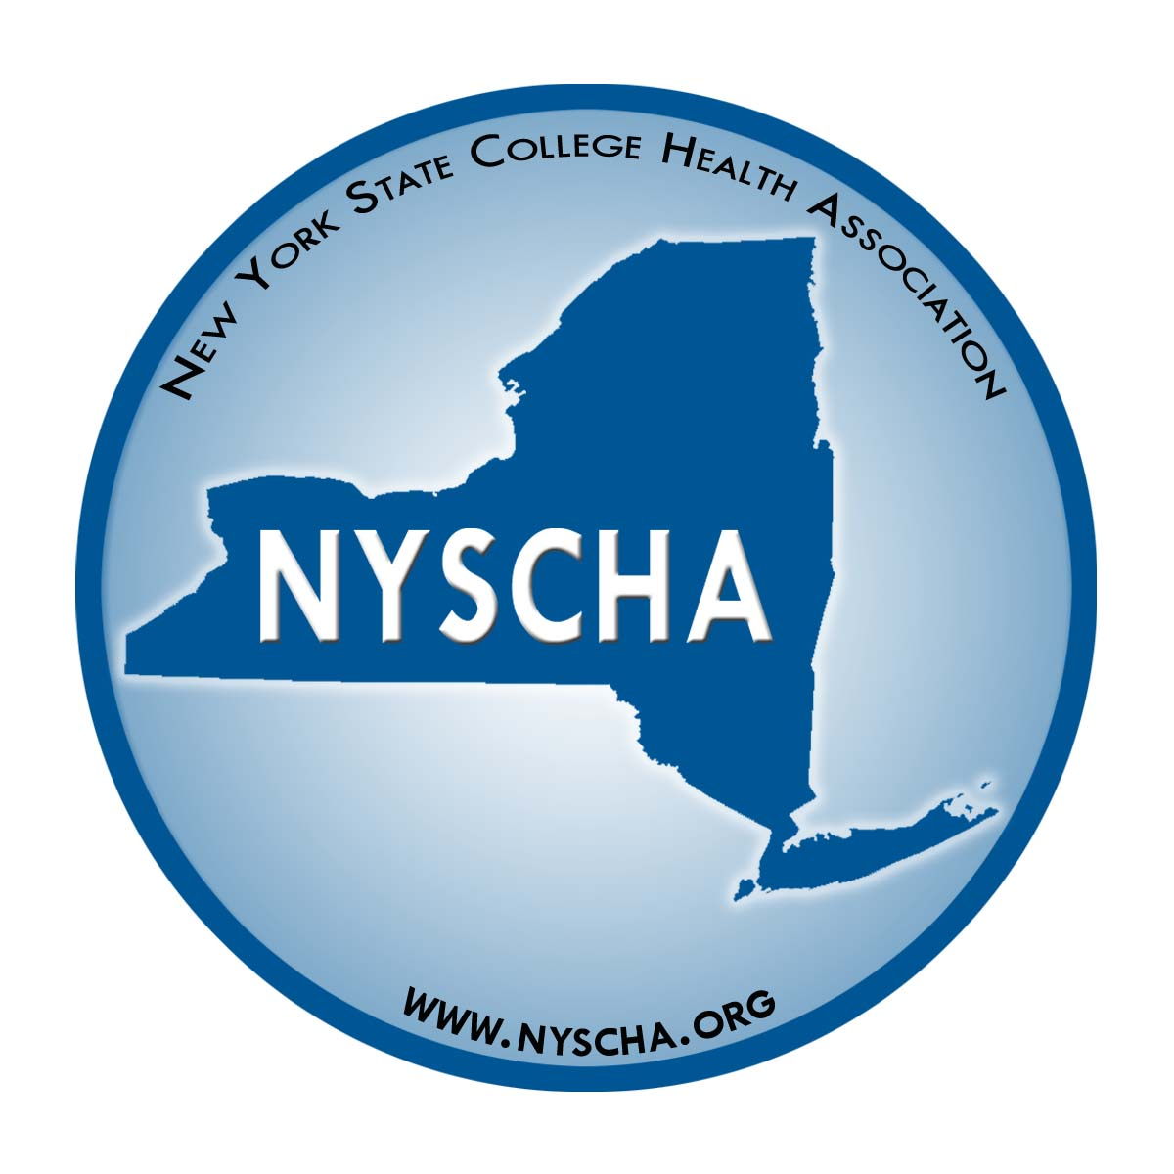
New York State College Health Association

www.NYSCHA.org

NYSCHA 2014
Professional Award

Name of Nominee:

College or University:

Person Submitting Application:
Your e-mail address:
Your daytime phone:
Your mailing address:
City/State/Zip:

Check the award name:
 Susan Shearer Award  Vincent Lamparella Award  Clifford B. Reifler Award

TO SUBMIT YOUR NOMINATION:

Send this nomination form and two recommendation letters to Paula Snyder, NYSCHA President Elect by Friday, October 3.
- By e-mail to: PaulaSnyder@mail.sunyjcc.edu
- By fax to: 716-376-7021
- By mail to: Paula Snyder, Director, College Health Services, Jamestown Community College, 260 N. Union Street, Olean, NY 14760

